Chapter 10, Problem 60.

Find the Thevenin equivalent of the circuit in Fig. 10.103 as seen from:

- terminals a-b
- terminals c-d

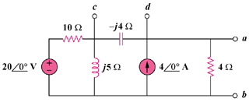

Figure 10.103
For Prob. 10.60.

